**Rate the media**

**Instructions**

In this exercise, you’ll create a web page for rating a video. The page will display a video player with playback controls. There will also be a HTML form for rating the video. The form will contain a slider element to rate video between 1 out of 5 and 5 out of 5.

**Instructions**

**Step 1:** First add a video element to the body element of the HTML document. Apply the controls attribute to enable playback controls.

**Step 2:** The width of the video will be 320 and the height will be 240. Apply the corresponding attributes to the video element.

**Step 3:** Next, add a source element to the video element.

**Step 4:** Set the src attribute of the source element to video.mp4 and the type attribute to video/mp4.

**Step 5:** After the video element add a form element.

**Step 6:**Add a div element to the form for the rating field.

**Step 7:** In the div element, add a label for the rating. Set the for attribute to rating.

**Step 8:** After the label, add an input element and set its type attribute to range.

**Step 9:** Set the id and name attributes to rating.

**Step 10:** Set the min attribute to 1 and the max attribute to 5.

**Step 11:** Set the list attribute value to ratings.

**Step 12:** After the input element, add a datalist element. Set its id attribute to ratings.

**Step 13:** Inside the datalist element, add five option elements.

**Step 14:** On the first option element, set its value attribute to 1 and its label attribute to 1.

**Step 15:** On the second option element, set its value attribute to 2.

**Step 16:** On the third option element, set its value attribute to 3.

**Step 17:** On the fourth option element, set its value attribute to 4.

**Step 18:** On the last option element, set its value attribute to 5 and its label attribute to 5.

**Step 19:** After the div element, add a button element and set its text to Submit Rating. Set the type attribute to submit.

**Step 20:** Save the HTML document and open Live Preview.

**Note** The video playback and dropdown selection element is not supported in Live Preview.

**Step 21:** Click the play button on the video and note the result.

**Tips**

* Review the Embedded Players lesson if you get stuck adding the video player.
* Review your cheat sheets from the previous week if you get stuck creating the form.

When the exercise is completed, the web page should match the following image.

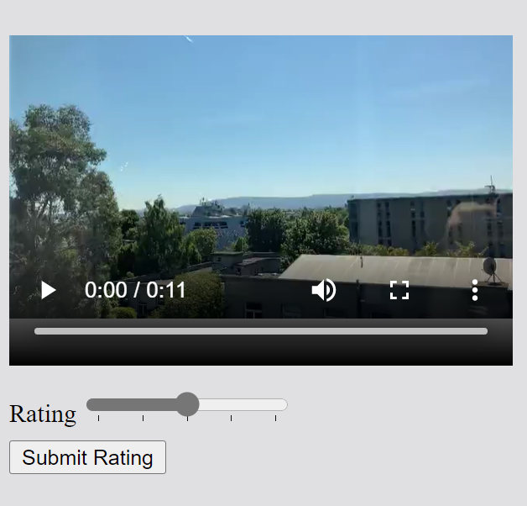

Solution

# Rate the media (solution)

The following is a sample solution to the previous exercise.

The code below is placed inside the <body> element of index.html.

  <video controls width="320" height="240">

    <source src="video.mp4" type="video/mp4">

  </video>

  <form>

    <div>

      <label for="rating">Rating</label>

      <input type="range" min="1" max="5" id="rating" name="rating" list="ratings">

      <datalist id="ratings">

          <option value="1" label="1"></option>

          <option value="2"></option>

          <option value="3"></option>

          <option value="4"></option>

          <option value="5" label="5"></option>

      </datalist>

    </div>

    <button type="submit">Submit Rating</button>

  </form>

While reviewing the code, note the following:

* The video element has a controls attribute to enable the video player controls (pause, volume, timeline, and so on).
* The video element contains a source element. The source element has a src attribute which specifies the video file to be played. It also has a type attribute to specify the video type, in this case it is an MP4 file.
* The input type for the rating is set to range. This will present a slider in the web browser. The min attribute is set to 1 and the max attribute is set to 5. The default range is 0 to 100 so these attributes need to be set so that the slider range matches the datalist.
* The range input has a list attribute set to ratings. This matches the id attribute of the datalist element below the input element.
* The datalist element contains the possible slider value and the corresponding label to display. When no label is specified for a value, no label will display on the slider for that value.

[Skip to Main Content](https://www.coursera.org/learn/html-and-css-in-depth/quiz/R3n5f/self-review-rate-the-media/attempt?redirectToCover=true#main)

[Higher Education Commission, Pakistan](https://www.coursera.org/programs/dlsei-phase-2b-iigii)

Top of Form

Search in course



Bottom of Form

1. • • [HTML and CSS in depth](https://www.coursera.org/learn/html-and-css-in-depth/home/welcome)

• [Week 1](https://www.coursera.org/learn/html-and-css-in-depth/home/week/1)

1. Self review: Rate the media

* • •

•

**[Video:](https://www.coursera.org/learn/html-and-css-in-depth/lecture/NHaRT/video-and-audio)** [VideoVideo and audio](https://www.coursera.org/learn/html-and-css-in-depth/lecture/NHaRT/video-and-audio)

[. Duration: 2 minutes2 min](https://www.coursera.org/learn/html-and-css-in-depth/lecture/NHaRT/video-and-audio)

•

•

**[Video:](https://www.coursera.org/learn/html-and-css-in-depth/lecture/VMsB2/embedded-players)** [VideoEmbedded players](https://www.coursera.org/learn/html-and-css-in-depth/lecture/VMsB2/embedded-players)

[. Duration: 3 minutes3 min](https://www.coursera.org/learn/html-and-css-in-depth/lecture/VMsB2/embedded-players)

•

•

**[Lab:](https://www.coursera.org/learn/html-and-css-in-depth/ungradedLab/scHQh/rate-the-media)** [Rate the media](https://www.coursera.org/learn/html-and-css-in-depth/ungradedLab/scHQh/rate-the-media)

[. Duration: 1 hour1h](https://www.coursera.org/learn/html-and-css-in-depth/ungradedLab/scHQh/rate-the-media)

•

•

**[Reading:](https://www.coursera.org/learn/html-and-css-in-depth/supplement/lQFTP/rate-the-media-solution)** [ReadingRate the media (solution)](https://www.coursera.org/learn/html-and-css-in-depth/supplement/lQFTP/rate-the-media-solution)

[. Duration: 10 minutes10 min](https://www.coursera.org/learn/html-and-css-in-depth/supplement/lQFTP/rate-the-media-solution)

•

•

**[Practice Quiz:](https://www.coursera.org/learn/html-and-css-in-depth/quiz/R3n5f/self-review-rate-the-media)** [Self review: Rate the media](https://www.coursera.org/learn/html-and-css-in-depth/quiz/R3n5f/self-review-rate-the-media)

[3 questions](https://www.coursera.org/learn/html-and-css-in-depth/quiz/R3n5f/self-review-rate-the-media)

•

•

**[Reading:](https://www.coursera.org/learn/html-and-css-in-depth/supplement/oCRtm/images)** [ReadingImages](https://www.coursera.org/learn/html-and-css-in-depth/supplement/oCRtm/images)

[. Duration: 10 minutes10 min](https://www.coursera.org/learn/html-and-css-in-depth/supplement/oCRtm/images)

•

•

**[Video:](https://www.coursera.org/learn/html-and-css-in-depth/lecture/8nTJT/iframes)** [VideoiFrames](https://www.coursera.org/learn/html-and-css-in-depth/lecture/8nTJT/iframes)

[. Duration: 2 minutes2 min](https://www.coursera.org/learn/html-and-css-in-depth/lecture/8nTJT/iframes)

•

•

**[Reading:](https://www.coursera.org/learn/html-and-css-in-depth/supplement/uaGN0/iframe-sandbox-cheat-sheet)** [ReadingiFrame sandbox cheat sheet](https://www.coursera.org/learn/html-and-css-in-depth/supplement/uaGN0/iframe-sandbox-cheat-sheet)

[. Duration: 20 minutes20 min](https://www.coursera.org/learn/html-and-css-in-depth/supplement/uaGN0/iframe-sandbox-cheat-sheet)

•

•

**[Video:](https://www.coursera.org/learn/html-and-css-in-depth/lecture/U6idM/iframe-as-a-picture)** [VideoiFrame as a picture](https://www.coursera.org/learn/html-and-css-in-depth/lecture/U6idM/iframe-as-a-picture)

[. Duration: 3 minutes3 min](https://www.coursera.org/learn/html-and-css-in-depth/lecture/U6idM/iframe-as-a-picture)

•

•

**[Video:](https://www.coursera.org/learn/html-and-css-in-depth/lecture/h4Las/the-canvas-element)** [VideoThe canvas element](https://www.coursera.org/learn/html-and-css-in-depth/lecture/h4Las/the-canvas-element)

[. Duration: 3 minutes3 min](https://www.coursera.org/learn/html-and-css-in-depth/lecture/h4Las/the-canvas-element)

•

•

**[Practice Quiz:](https://www.coursera.org/learn/html-and-css-in-depth/quiz/Obx4v/knowledge-check-media-elements)** [Knowledge check: Media elements](https://www.coursera.org/learn/html-and-css-in-depth/quiz/Obx4v/knowledge-check-media-elements)

[6 questions](https://www.coursera.org/learn/html-and-css-in-depth/quiz/Obx4v/knowledge-check-media-elements)

•

•

**[Video:](https://www.coursera.org/learn/html-and-css-in-depth/lecture/xWsIF/module-summary-html-deep-dive)** [VideoModule summary: HTML deep dive](https://www.coursera.org/learn/html-and-css-in-depth/lecture/xWsIF/module-summary-html-deep-dive)

[. Duration: 2 minutes2 min](https://www.coursera.org/learn/html-and-css-in-depth/lecture/xWsIF/module-summary-html-deep-dive)

•

•

**[Quiz:](https://www.coursera.org/learn/html-and-css-in-depth/exam/9GD8K/module-quiz-html-deep-dive)** [Module quiz: HTML deep dive](https://www.coursera.org/learn/html-and-css-in-depth/exam/9GD8K/module-quiz-html-deep-dive)

[10 questions](https://www.coursera.org/learn/html-and-css-in-depth/exam/9GD8K/module-quiz-html-deep-dive)

•

**[Reading:](https://www.coursera.org/learn/html-and-css-in-depth/supplement/0Rjn4/additional-resources)** [ReadingAdditional resources](https://www.coursera.org/learn/html-and-css-in-depth/supplement/0Rjn4/additional-resources)

[. Duration: 10 minutes10 min](https://www.coursera.org/learn/html-and-css-in-depth/supplement/0Rjn4/additional-resources)

# Self review: Rate the media

Practice Quiz10 minutes • 10 min

### Submit your assignment

### Receive grade

To Pass 80% or higher

### Your grade

100%

We keep your highest score

# Self review: Rate the media

Practice Quiz. • 10 min. • 3 total points available.3 total points

## • Congratulations! You passed!

Grade received 100%

To pass 80% or higher

### 1.

Question 1

When you clicked the play button on the video, what was the result?

1 / 1 point



The video started playing.



The video did not play.

Correct

Correct. The video will start playing.

### 2.

Question 2

You used the range type for the ratings input field. How did you define its possible values? Select all that apply.

1 / 1 point



Using a datalist element

Correct

Correct. The datalist element sets the values and labels possible within the range.



Using the min attribute

Correct

Correct. The min attribute sets the minimum value.



Using the max attribute

Correct

Correct. The max attribute sets the maximum value.

### 3.

Question 3

Which element specified which video file to be played?

1 / 1 point



The source element



The video element



The src element

Correct

Correct. The src attribute of the source element specifies the video file to be played.